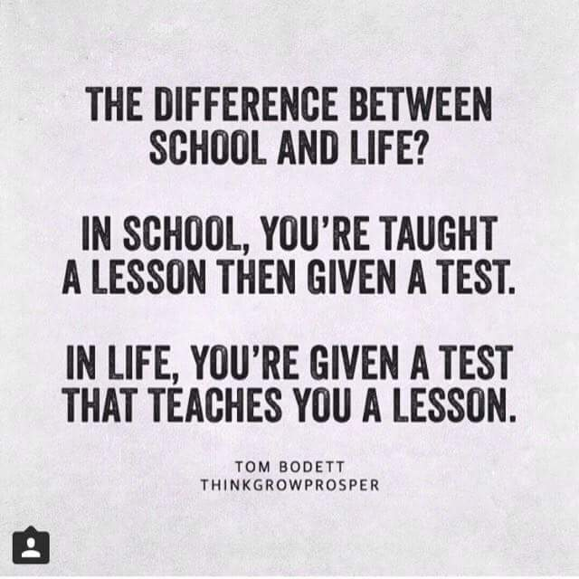

Food For Thought
As we approach the end of the academic year, I would like to thank all of you for the effort you have put into the success of the school. We have started a journey towards a brighter future and without doubt, are moving towards this goal. I appreciate that sometimes it might not appear that there is a purpose, but believe me there is.
Because of this, I know some of you staff and learners are extremely positive and committed to creating a school to be hugely proud of. To these people I say “let’s make it even better – the future has hope and optimism and this boat has a direction and a purpose”
I also know that some of you are quite indifferent, happy when things go well and grumpy when they don’t. To you I say “ You are on this boat, its moving forward, keep focused and keep the belief that things will continue to improve and you can be part of the success story”
And then there are those who remain pessimistic and negative, unable to embrace the change needed to achieve, feeding on criticism and blame .

To this group I say “ seek the willingness to change the things you can, the serenity to accept that which cannot be change, the wisdom to know the difference. And remember- if you drill holes in the boat we will all sink together!

School opens for Term 4 on the 9th October 2018
Contact Us

Office Tel / Fax: 0154911794
Email:admin@meps.za.org
Email: accounts@meps.za.org
School Hours
Mon -Thu: 7.00 am – 13.30pm
Fri: 7.00 am – 12.00pm
19 Kiepersol Street
PO Box 3635
Mokopane
0600
www.mecschool.co.za

Thanks

Thursday, September 20, 2018
Important Dates
- Tuesday 9 October School re-opens
- Thursday 18 October NSC start
- Friday 19 October Primary School Prefect Leadership Workshop
- Tuesday 23 October CANSA Toktokkie Day Gr 4-12 Foundation Phase Toktokkie Fund Raiser

NEWSLETTER TITLE

Mokopane English Combined School
MECS MATTERS

