

TERM 3 WEEK 3
WEDNESDAY 22 JULY 2020
DAILY REVISION :
- Days of the week
- Months of the year
- Seasons of the year
- Write your name and surname 3 x
- Learn your address and telephone number
- Phonics from the Busy Bee Book

THEME DISCUSSION : FARM ANIMALS
Do you know some of the animals that we find on a farm? This week we will be learning more about farm animals . We will learn about the different types of animals, the sounds they make, why do we farm with them and what do we get from them.

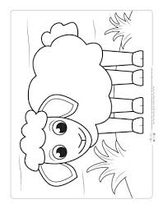

NEW LETTER INTRODUCTION:
Now v and w are family. They stay together happily. V is down and up that’s all. W does it twice but still stays small.
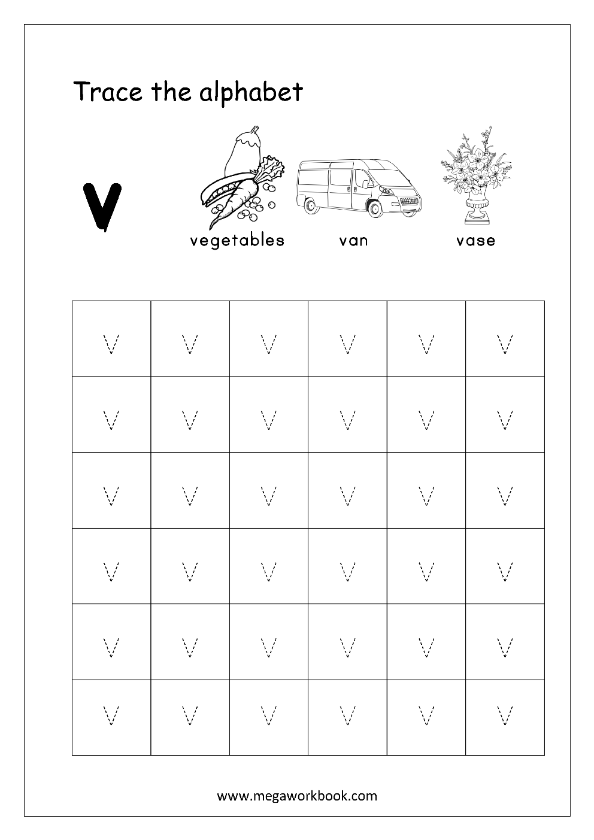
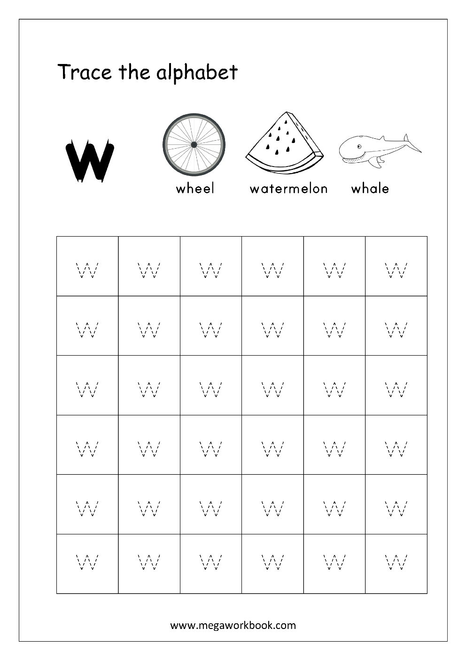

EMERGENT READING: - ad family words
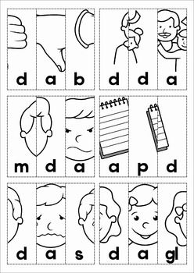
NUMERACY:

COUNT FROM 1 – 50

Count with your child from 1 upto 50. Then let them count by themselves.

COUNT BACKWARDS FROM 12 – 1

Count with your child backwards from 12 – 1.
12 11 10 9 8 7 6 5 4 3 2 1
Then let them count by themselves.

COUNTING IN TWO’S

Count with your child in 2’s and then let them count for you.
2 4 6 8 10 12 14 16 18 20

TRACING NUMBERS 1 – 10

Trace over the numbers three times.

ADDING AND SUBTRACTING WITH ZERO 0

Complete the worksheet as per the instructional video.

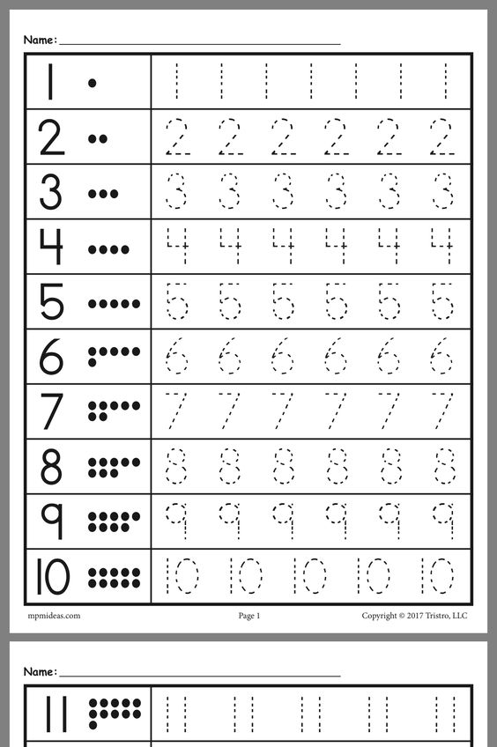
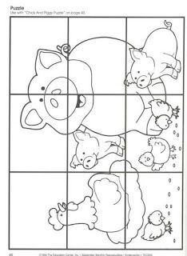

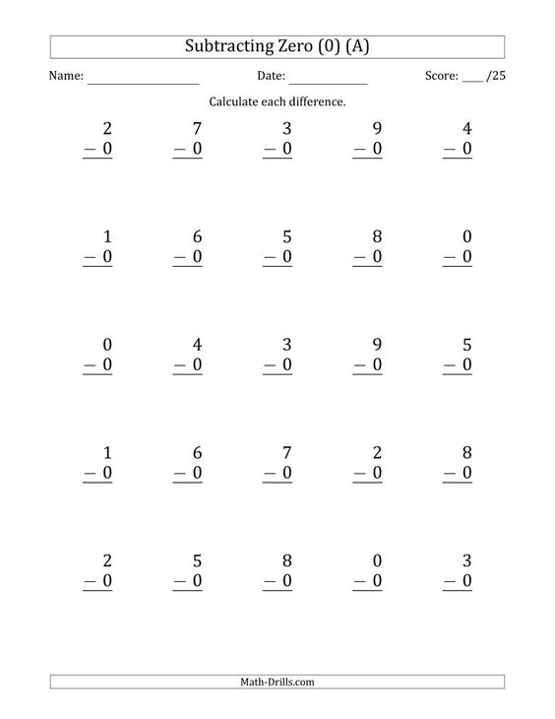

WORKBOOK

Complete the stipulated number of pages daily as per the instructional video.

