
TERM 3 WEEK 4
THURSDAY 30 JULY 2020

DAILY REVISION OF:
- Counting
- Shapes
- Seasons of the year
- Months of the year
- Days of the week
- Phonics
- Write your name and surname

NEW LETTER INTRODUCTION:
Letter t and y
Y is hanging like washing, ready to dry. Like u here is a y to try. Down and round and up and down again. Now give him a tail, he’ll be prettier then.

Tt down and round, you’re nearly done. t is easy and lots of fun. Now make a cross straight on the line.

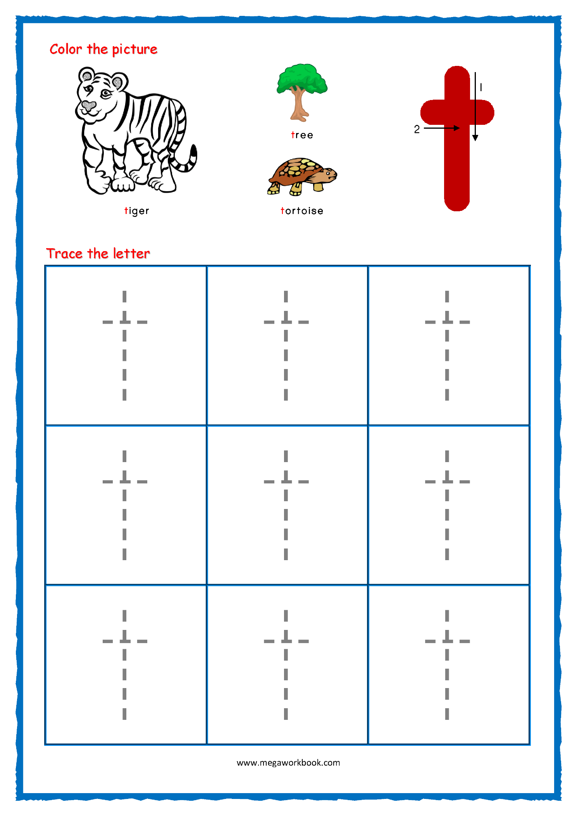

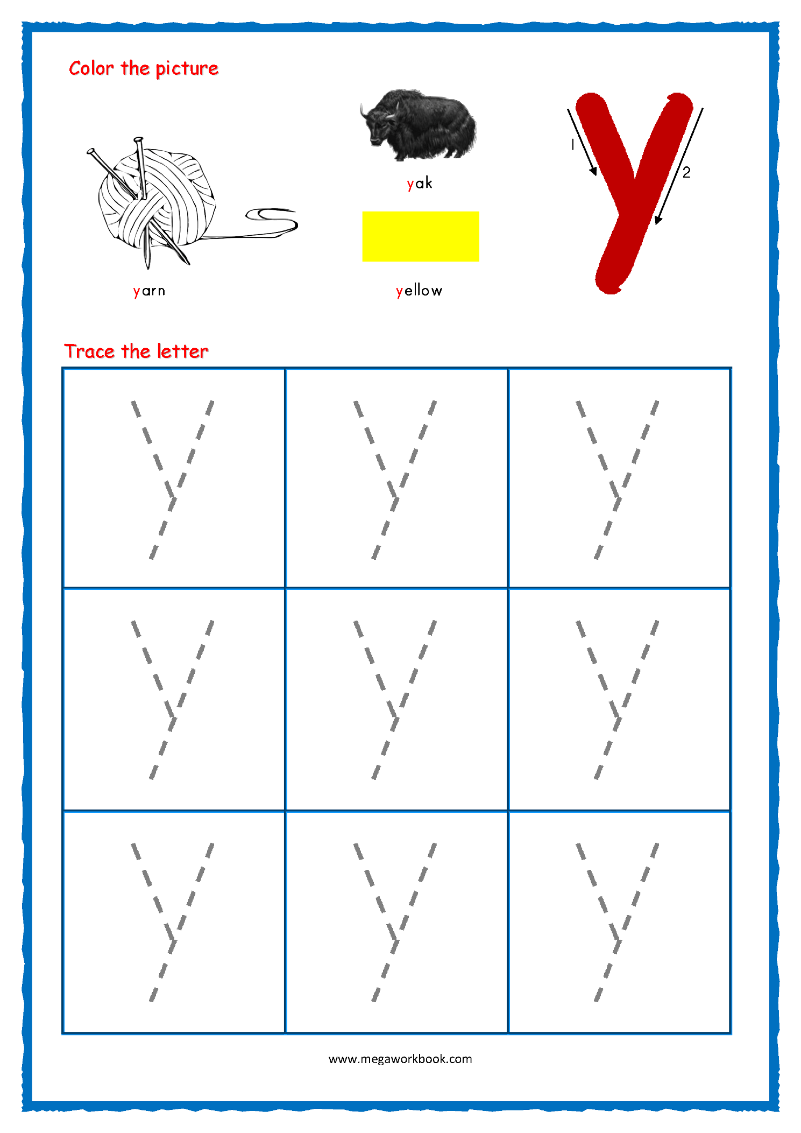

EMERGENT READING
Follow the video to read along from your Busy Bee Book.
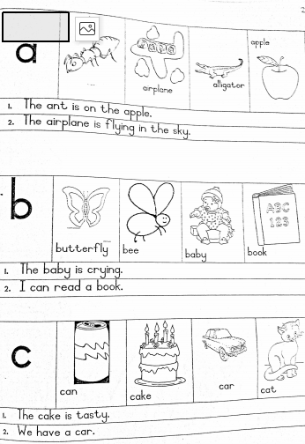
NUMERACY:

COUNT FROM 1 – 50

Count with your child from 1 upto 50. Then let them count by themselves.

COUNT BACKWARDS FROM 20 – 1

Count with your child backwards from 20 – 1.
20 19 18 17 16 15 14 13 12 11 10 9 8 7 6 5 4 3 2 1
Then let them count by themselves.

COUNTING IN TWO’S

Count with your child in 2’s and then let them count for you.
2 4 6 8 10 12 14 16 18 20 22 24 26 28 30

TRACING NUMBERS 11-20

Trace over the numbers three times.

ADDING AND SUBTRACTING

Complete the worksheets as per the instructional video.

NUMBER NAMES

Practice writing number names





