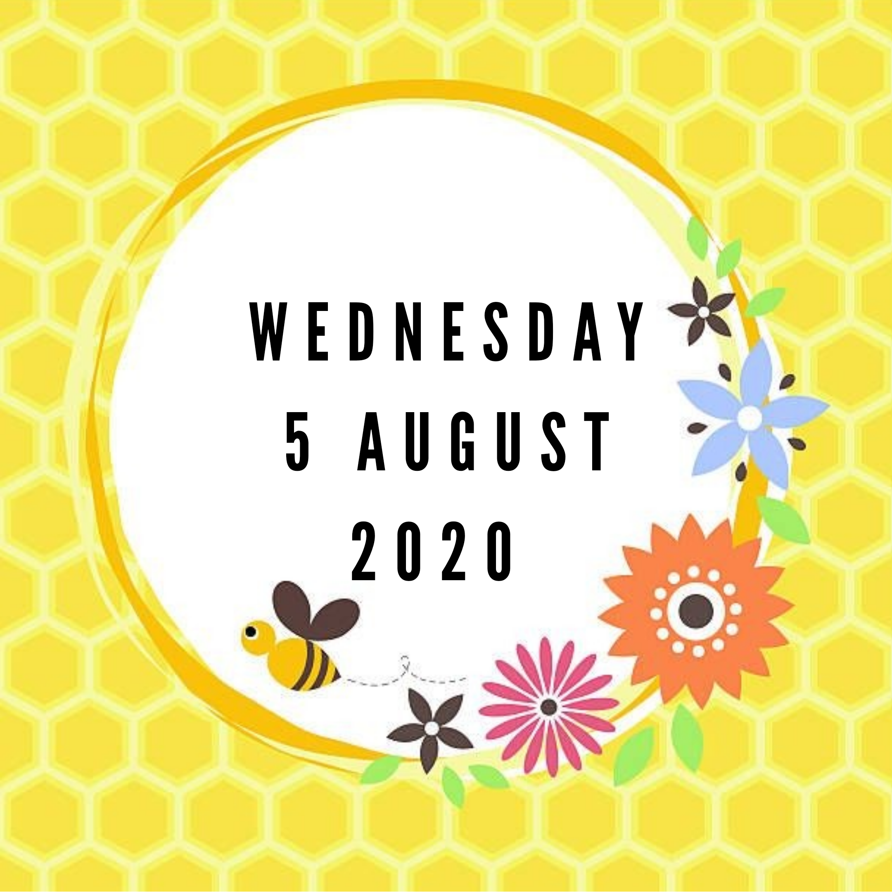

TERM 3 WEEK 5
WEDNESDAY 5 AUGUST 2020

DAILY REVISION OF:
- Counting
- Shapes
- Seasons of the year
- Months of the year
- Days of the week
- Phonics
- Write your name and surname

THEME DISCUSSION:
This week we will be learning more about the wonderful world of insects. Have fun colouring in the pictures and learning something new from the daily You Tube videos.

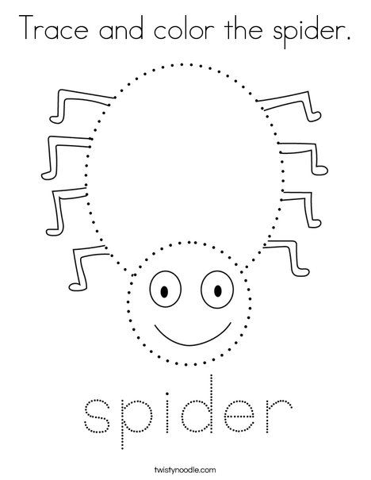

NEW LETTER INTRODUCTION:
X is so easy . Down right to left then left to right.
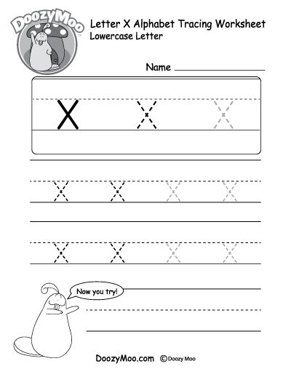
z- the letter z is a bit tricky. Take it slow or he’ll get sticky. From left to right you draw a line. Then zag it down, you’re doing fine. Now zig it to your right again. That is z there and then.
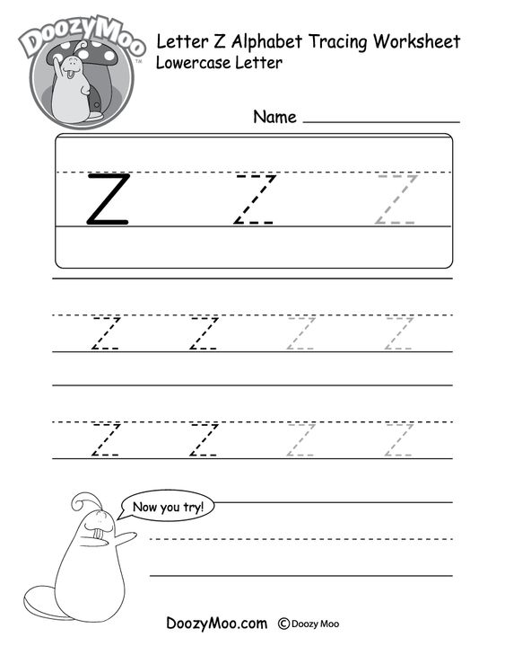

EMERGENT READING:
Watch the instructional video and read along in your Busy Bee Book.
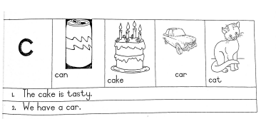
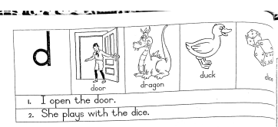

TRACING WORKSHEETS.
Let’s practice our fine motor skills this week by completing the pattern worksheets.
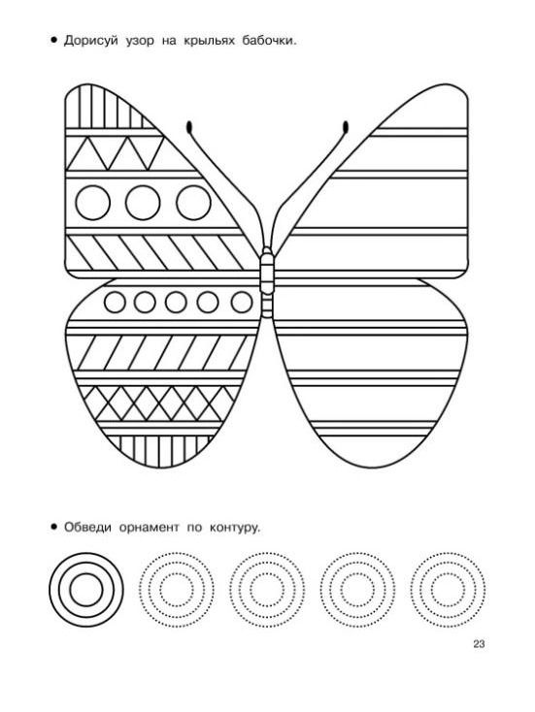
NUMERACY:

COUNT FROM 1 – 50

Count with your child from 1 upto 50. Then let them count by themselves.

COUNT BACKWARDS FROM 20 – 1

Count with your child backwards from 20 – 1.
20 19 18 17 16 15 14 13 12 11 10 9 8 7 6 5 4 3 2 1
Then let them count by themselves.

COUNTING IN TWO’S

Count with your child in 2’s and then let them count for you.
2 4 6 8 10 12 14 16 18 20 22 24 26 28 30
NUMERACY WORKSHEETS:

Complete the worksheets provided for the day.
NUMBER NAMES

Practice writing number names
