

TERM 3 WEEK 6
THURSDAY 13 AUGUST 2020

DAILY REVISION OF:
- Counting
- Shapes
- Seasons of the year
- Months of the year
- Days of the week
- Phonics
- Write your name and surname

THEME DISCUSSION:
This week we will be learning more about Spring!! Winter is almost over and a new season is upon us.. We will soon be packing up our winter warmers and time for butterflies and ice cream..

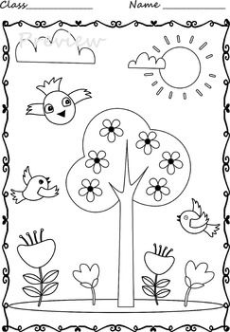
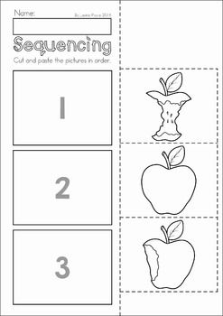

SH BLEND WORDS ( DIGRAPHS)


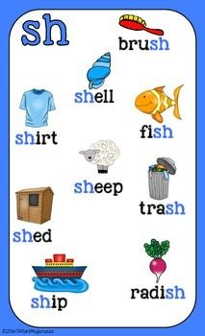
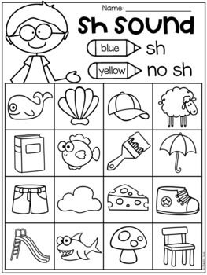

EMERGENT READING:
Watch the instructional video and read along in your Busy Bee Book.
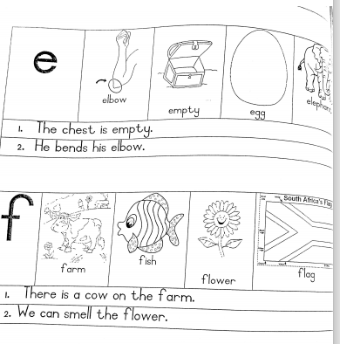

NUMERACY:

COUNT FROM 1 – 50

Count with your child from 1 upto 50. Then let them count by themselves.

COUNT BACKWARDS FROM 20 – 1

Count with your child backwards from 20 – 1.
20 19 18 17 16 15 14 13 12 11 10 9 8 7 6 5 4 3 2 1
Then let them count by themselves.

COUNTING IN TWO’S

Count with your child in 2’s and then let them count for you.
2 4 6 8 10 12 14 16 18 20 22 24 26 28 30
NUMERACY WORKSHEETS:

Complete the worksheets provided for the day.
NUMBER NAMES

Practice writing number names
