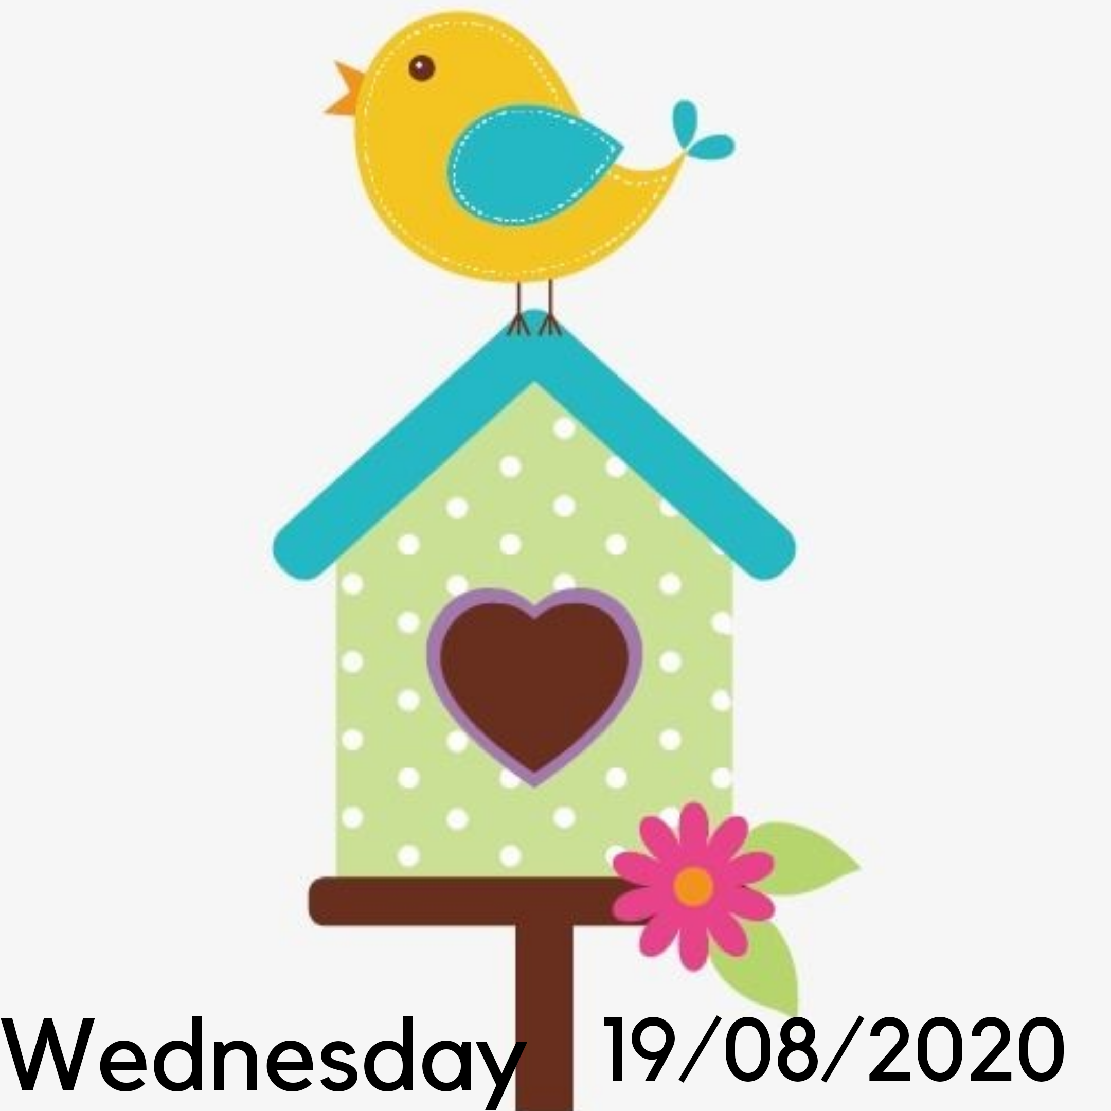

TERM 3 WEEK 7
WEDNESDAY 19 AUGUST 2020

DAILY REVISION OF:
- Counting
- Shapes
- Seasons of the year
- Months of the year
- Days of the week
- Phonics
- Write your name and surname

THEME DISCUSSION:
This week we will be learning more about birds!! Winter is almost over and a new season is upon us.. Soon we will begin to see more birds returning because of the warmer weather.

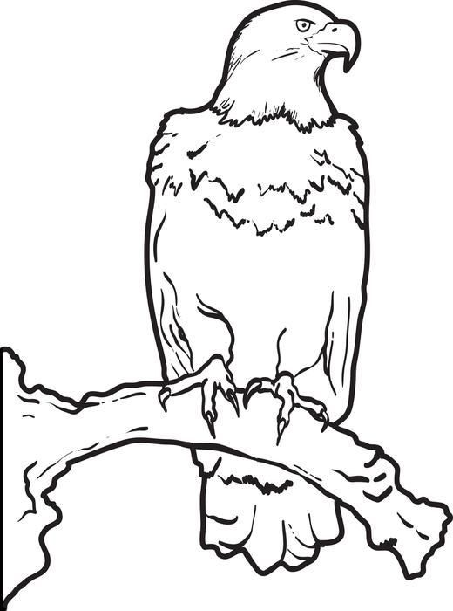
Ch BLEND SOUNDS (DIGRAPHS)
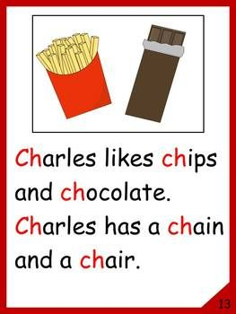

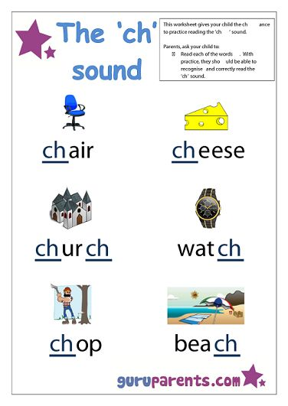

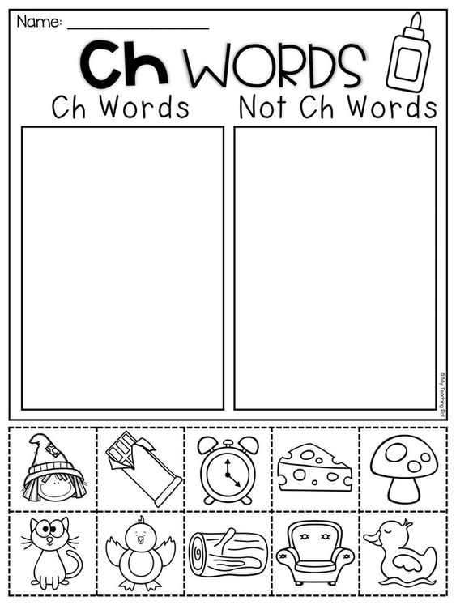
EMERGENT READING
Read along with me and follow in your Busy Bee Book.
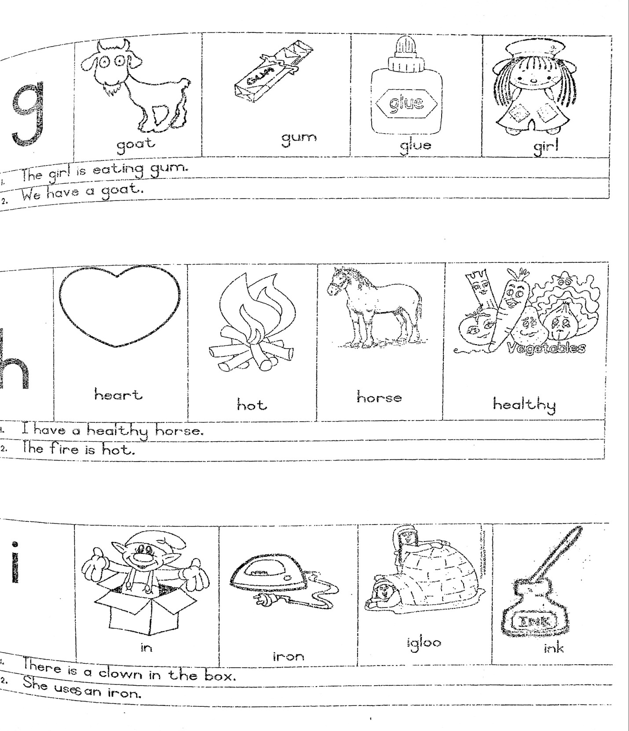
NUMERACY:

COUNT FROM 1 – 50

Count with your child from 1 upto 50. Then let them count by themselves.

COUNT BACKWARDS FROM 20 – 1

Count with your child backwards from 20 – 1.
20 19 18 17 16 15 14 13 12 11 10 9 8 7 6 5 4 3 2 1
Then let them count by themselves.

COUNTING IN TWO’S

Count with your child in 2’s and then let them count for you.
2 4 6 8 10 12 14 16 18 20 22 24 26 28 30
NUMERACY WORKSHEETS:

Complete the worksheets provided for the day.
NUMBER NAMES

Practice writing number names




