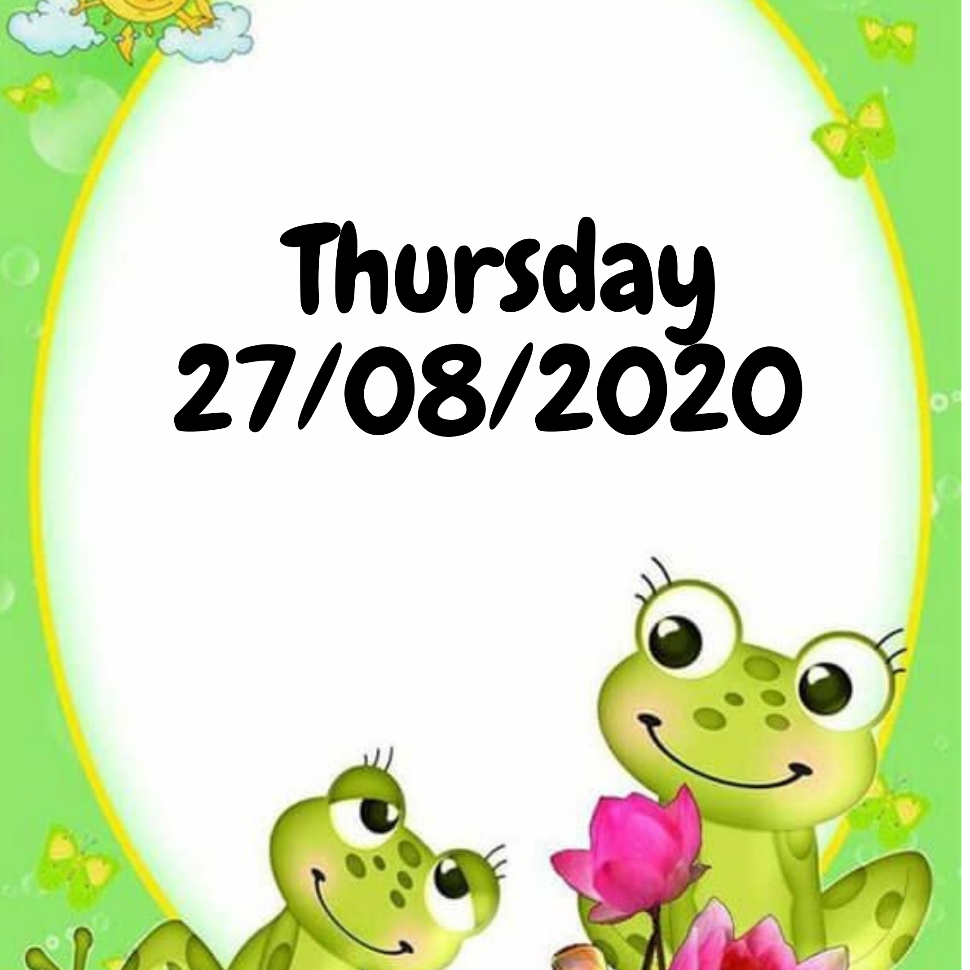

TERM 3 WEEK 8
THURSDAY 27 AUGUST 2020

DAILY REVISION OF:
- Counting
- Shapes
- Seasons of the year
- Months of the year
- Days of the week
- Phonics
- Write your name and surname

THEME DISCUSSION:
This week we will be learning more about reptiles!!
Reptiles are animals like snakes, turtles, tortoises, lizards, geckos, chameleons, iguanas, crocodiles, etc..

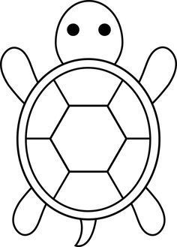
th BLEND SOUNDS (DIGRAPHS)
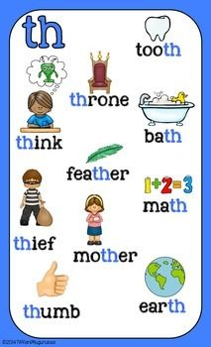

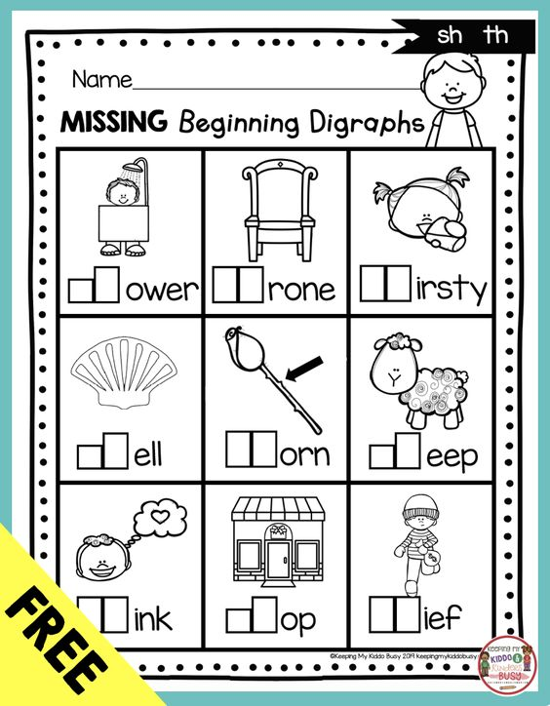

EMERGENT READING
Read along with me and follow in your Busy Bee Book.
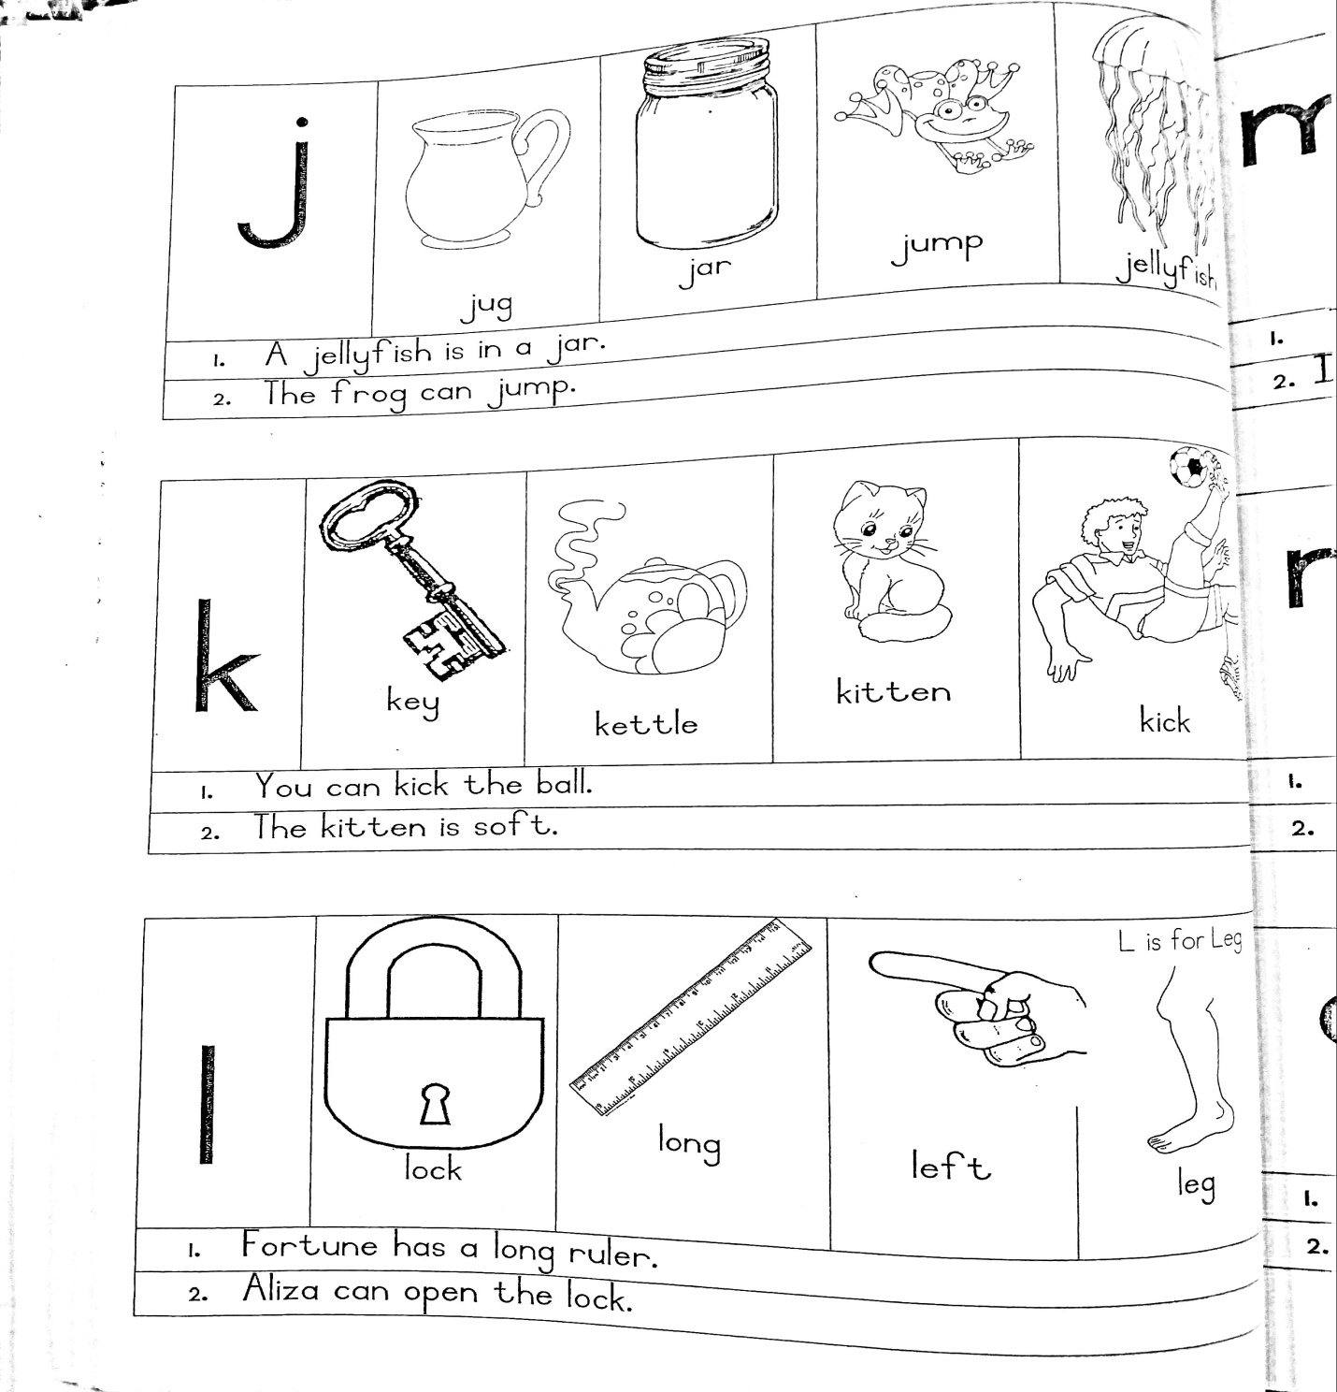

NUMERACY:

COUNT FROM 1 – 50

Count with your child from 1 upto 50. Then let them count by themselves.

COUNT BACKWARDS FROM 30 – 1

Count with your child backwards from 30 – 1.

Then let them count by themselves.

COUNTING IN TENS

Count with your child in 10’s and then let them count for you.
10 20 30 40 50 60 70 80 90 100

NUMERACY WORKSHEETS:
Complete the worksheets provided for the day.

NUMBER NAMES
Practice writing number names
